**SCIENCE PAPER TWO**

*Time: 2:15minutes*

**Pupil’s name :……………………………………………… Index No……………........**

**SECTION MARKS**

**B**

**A**

**DO NOT OPEN THIS BOOKLET UNTIL YOU ARE TOLD TO DO SO**

**Read the following instructions carefully.**

**T**

1. **Read the instructions carefully**

1. **Answer ALL questions in Section A & B**
2. **Answers should be put in the space provided.**
3. **All answers should be written in blue or black ink.**
4. **Unnecessary alterations may lead to loss of marks**
5. **Any handwriting that cannot be read may lead to loss of marks.**
6. In which state of matter does heat travel fastest?

____________________________________________________________________

1. How is measles vaccine administered?

____________________________________________________________________

1. Identify one activity done to prevent domestic rabbits from digging barrows in the ground.

____________________________________________________________________

1. In the space below, draw a simple serrated leaf.
2. How do soft materials like soft boards control echoes in cinema halls?

____________________________________________________________________

1. Give one way in which you can control common weeds in the garden.

____________________________________________________________________

1. In which way is the function of a fuse similar to that of a switch?

____________________________________________________________________

1. Write one non chemical way of controlling malaria in the community.

____________________________________________________________________

1. Name one food deficiency disease.

____________________________________________________________________

1. How do medical workers reset clinical thermometers after use?

____________________________________________________________________

1. State any one human body sense.

____________________________________________________________________

1. How is the human skeleton important to the circulatory system?

____________________________________________________________________

1. Convert 600C to the Fahrenheit scale.

____________________________________________________________________

1. How do treads on soles and tyres increase friction?

____________________________________________________________________

1. State one activity that you can do to keep clean.

____________________________________________________________________

1. Identify one way a bee keeper can control swarming of bees.

____________________________________________________________________

1. Why do lions live in bushes yet they don’t feed on vegetation?

____________________________________________________________________

1. Give one way of conserving energy at home.

____________________________________________________________________

1. Name any one gear used by people to manage the rainy weather.

____________________________________________________________________

1. State one health life style that can be used to prevent ringworm in a home.

____________________________________________________________________

**Study the diagram below and use it to answer questions 21 and 22**

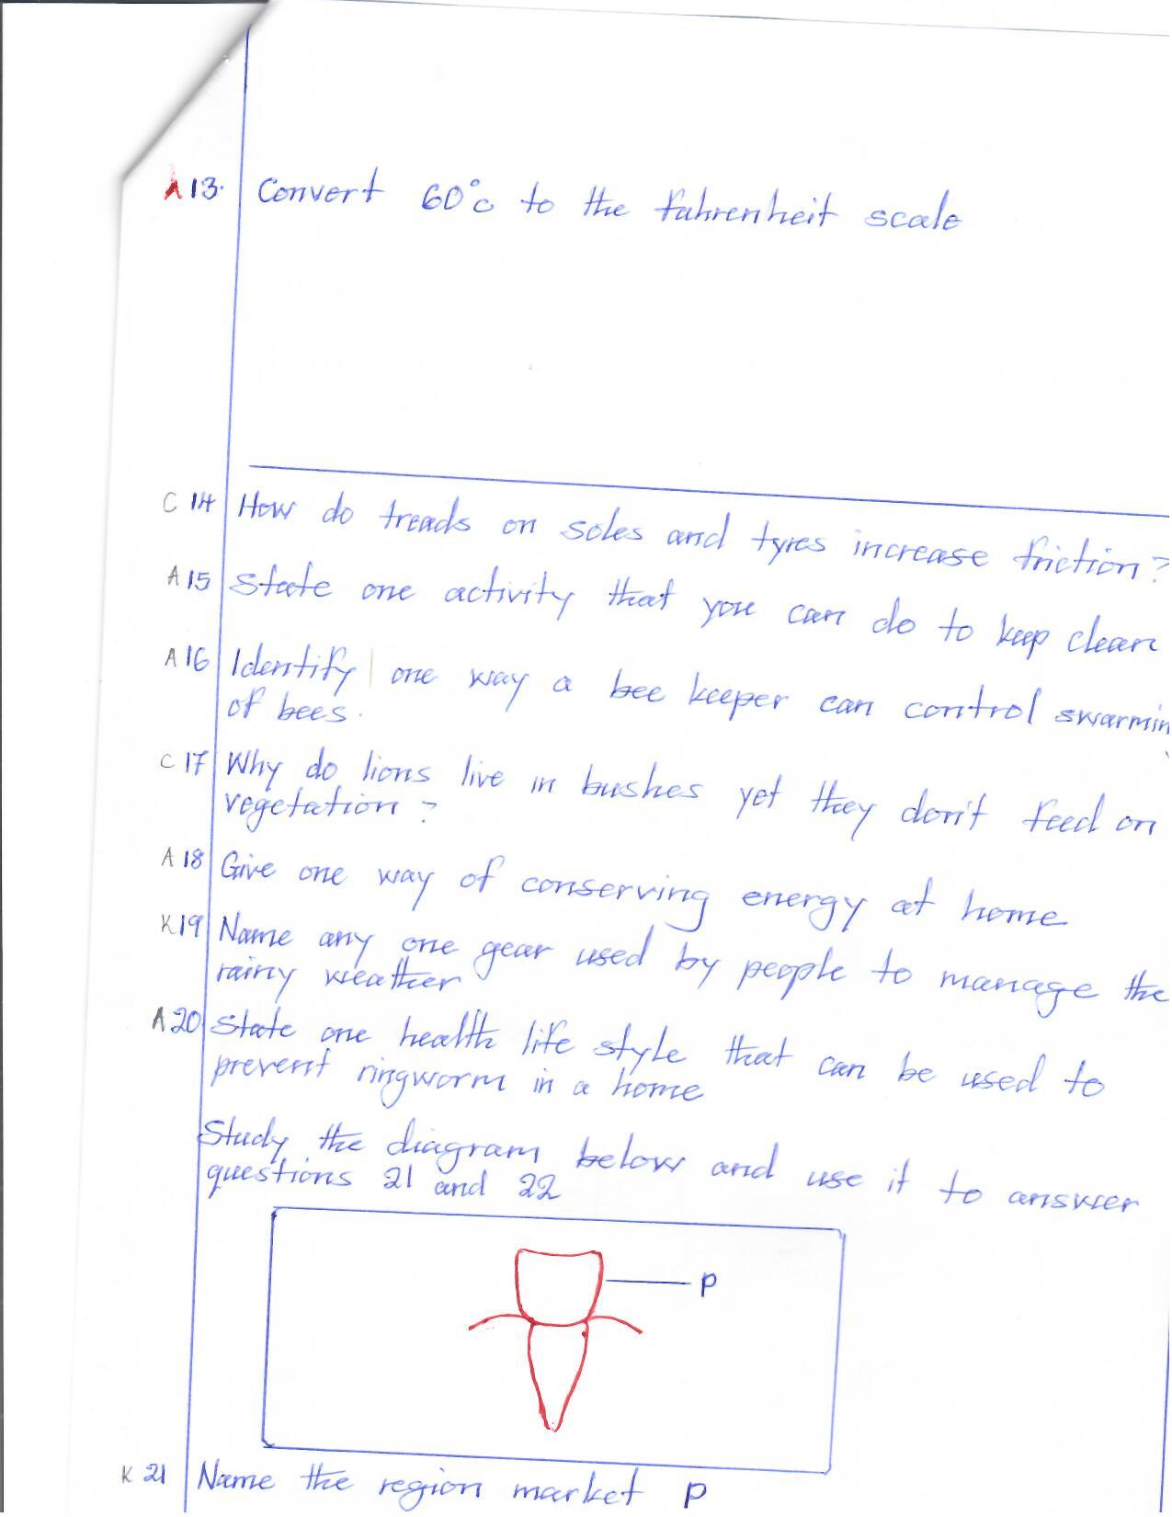

1. Name the region marked p.

____________________________________________________________________

1. How is the above tooth adapted to its function?

____________________________________________________________________

1. Give any one way of preventing soil exhaustion.

____________________________________________________________________

1. Why do some farmers prefer keeping goats to cattle?

____________________________________________________________________

1. State any one way of caring for the human eye.

____________________________________________________________________

1. Which activity can you do to ease the drying of washed clothes?

____________________________________________________________________

1. Why are mushrooms not regarded as plants?

____________________________________________________________________

1. Identify one way of controlling house flies in a pit latrine.

____________________________________________________________________

1. Write any one characteristic of vertebrates besides having backbones.

____________________________________________________________________

1. Why are most iron sheets painted these days?

____________________________________________________________________

1. How can short sightedness be corrected?

____________________________________________________________________

1. Name any one breed of rabbits kept in Uganda.

____________________________________________________________________

1. State any one way of storing sound for future reference.

____________________________________________________________________

**Study the property of air below and answer questions 34 and 35 about it**

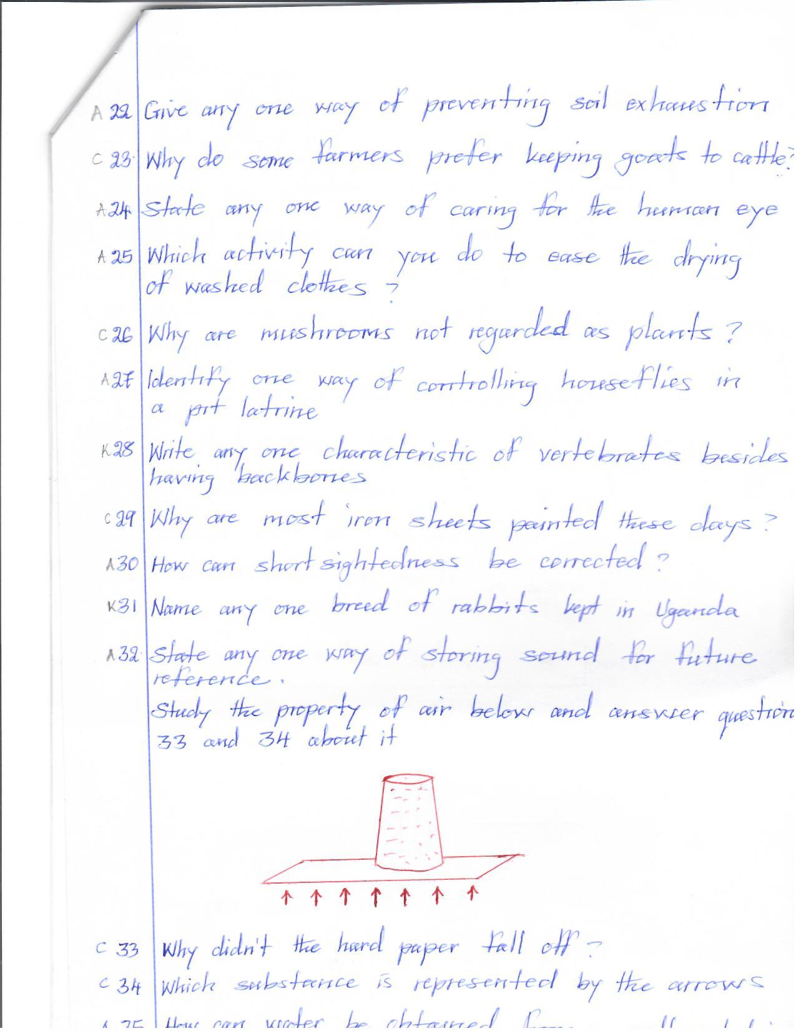

1. Why didn’t the hard paper fall off?

____________________________________________________________________

1. Which substance is represented by the arrows?

____________________________________________________________________

1. How can water be obtained from a self solution?

____________________________________________________________________

1. What enables geckos to move upside down on ceiling boards?

____________________________________________________________________

1. State the difference between mass and density.

____________________________________________________________________

____________________________________________________________________

1. How do some factories in Uganda make use of conifers?

____________________________________________________________________

1. Give the meaning of the term electrical resistance.

____________________________________________________________________

**SECTION B: 60 MARKS**

1. a) By what process does dew form on plants?

____________________________________________________________________

b) Why does dew commonly form at night?

____________________________________________________________________

c) What causes dew to disappear during day?

____________________________________________________________________

d) In which state of matter is dew?

____________________________________________________________________

1. 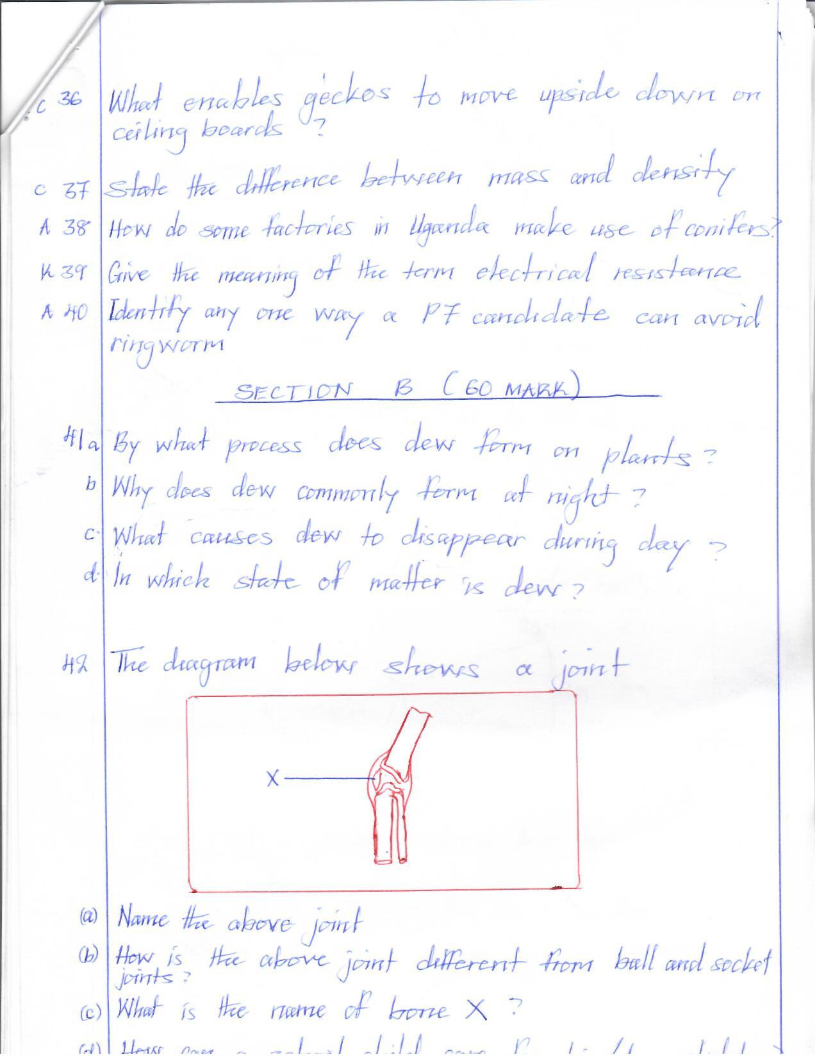**The diagram below shows a joint, use it to answer the questions that follow**

a) Name the above joint.

____________________________________________________________________

b) How is the above joint different from ball and socket joints?

____________________________________________________________________

c) What is the name of bone x?

____________________________________________________________________

d)How can a school child care for his/ her skeleton?

____________________________________________________________________

1. a) What is PHC?

____________________________________________________________________

b) Give any two importance of PHC in a community.

i)________________________________________________________________

ii)________________________________________________________________

1. Write any one principle of PHC.

_________________________________________________________________

1. a) Identify the tuber crop which is attached by white flies.

____________________________________________________________________

b) How are white flies dangerous to the above tuber crop?

____________________________________________________________________

c) State two ways of controlling tuber crop pests.

i)___________________________________________________________________

ii)___________________________________________________________________

1. **Study the diagram of the simple machine below**

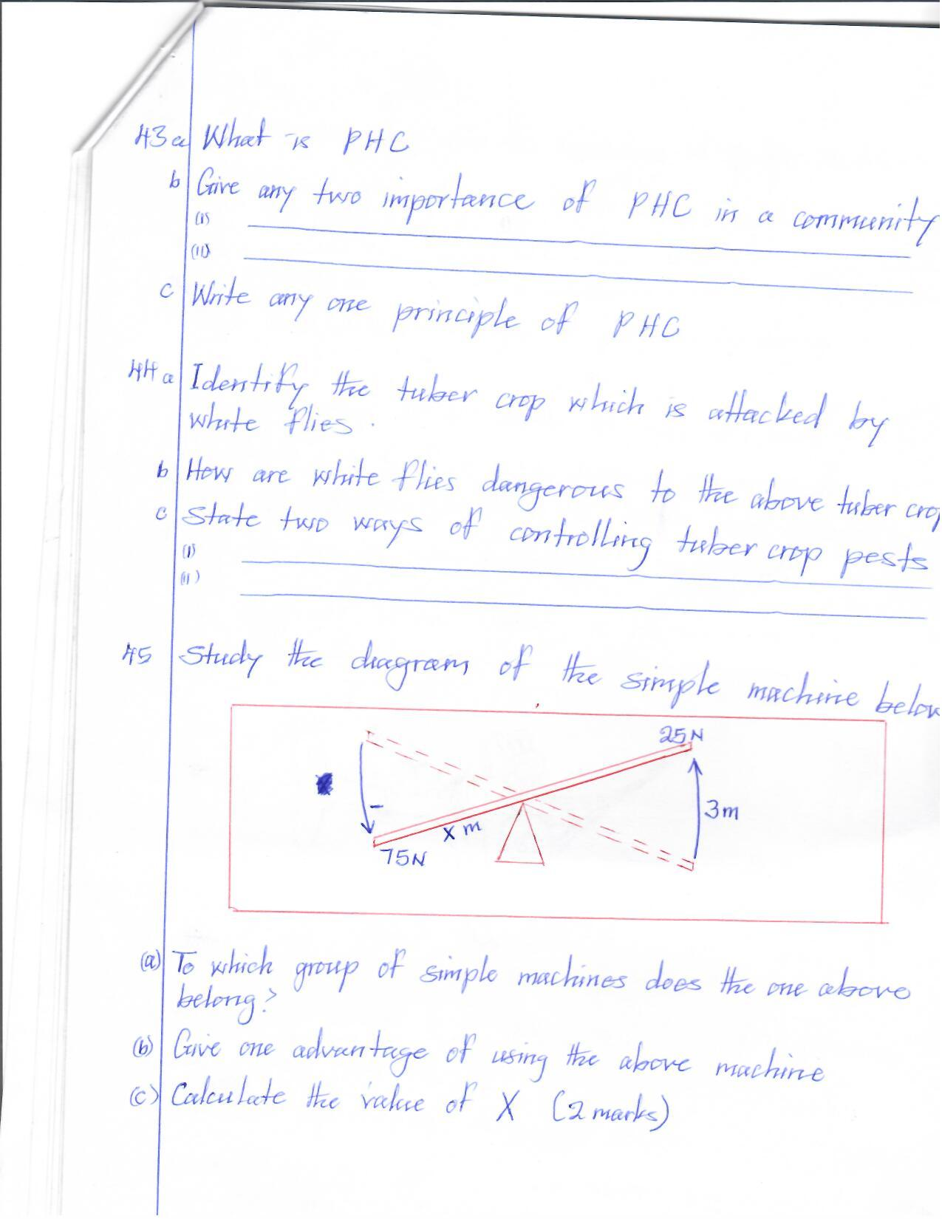

a) To which group of simple machines does the one above?

____________________________________________________________________

b) Give one advantage of using the above machine.

____________________________________________________________________

c) Calculate the value of x (2marks)

____________________________________________________________________

1. a) In one sentence, give the meaning of bottle feeding.

____________________________________________________________________

b) Give any two conditions under which bottle feeding can be recommended.

i)___________________________________________________________________

ii)___________________________________________________________________

c) Write one disadvantage of bottle feeding.

____________________________________________________________________

1. a) On which part of a spider are legs attached?

____________________________________________________________________

b) To which group of animals does a spider belong?

____________________________________________________________________

c) Give one difference between a spider and a mosquito.

____________________________________________________________________

____________________________________________________________________

1. Why are spiders regarded as important animals?

____________________________________________________________________

1. 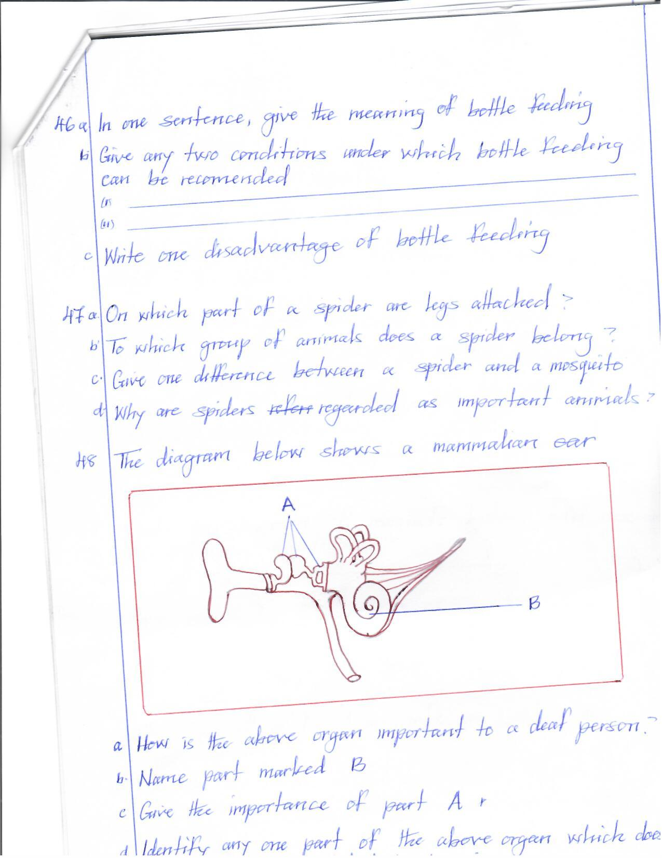**The diagram below shows a mammalian ear**
2. How is the above organ important to a deaf person?

_________________________________________________________________

1. Name part marked B.

_________________________________________________________________

1. Give the importance of part A.

_________________________________________________________________

1. Identify any one part of the above organ which doesn’t have any function related to hearing.

_________________________________________________________________

1. a) Which chambers of the heart is responsible for pumping blood?

____________________________________________________________________

b) How are heart valves important?

____________________________________________________________________

c) In which body cavity is the human heart found?

____________________________________________________________________

d) Identify any one way of increasing the volume of blood in the body.

____________________________________________________________________

1. a) Name any one breed of cattle kept in Uganda.

____________________________________________________________________

b) What is the main purpose of rearing the above named cattle breed?

____________________________________________________________________

c) State any two ways of controlling cattle diseases without using chemicals.

i)___________________________________________________________________

ii)___________________________________________________________________

1. **Study the diagram of magnets below and answer the following questions**

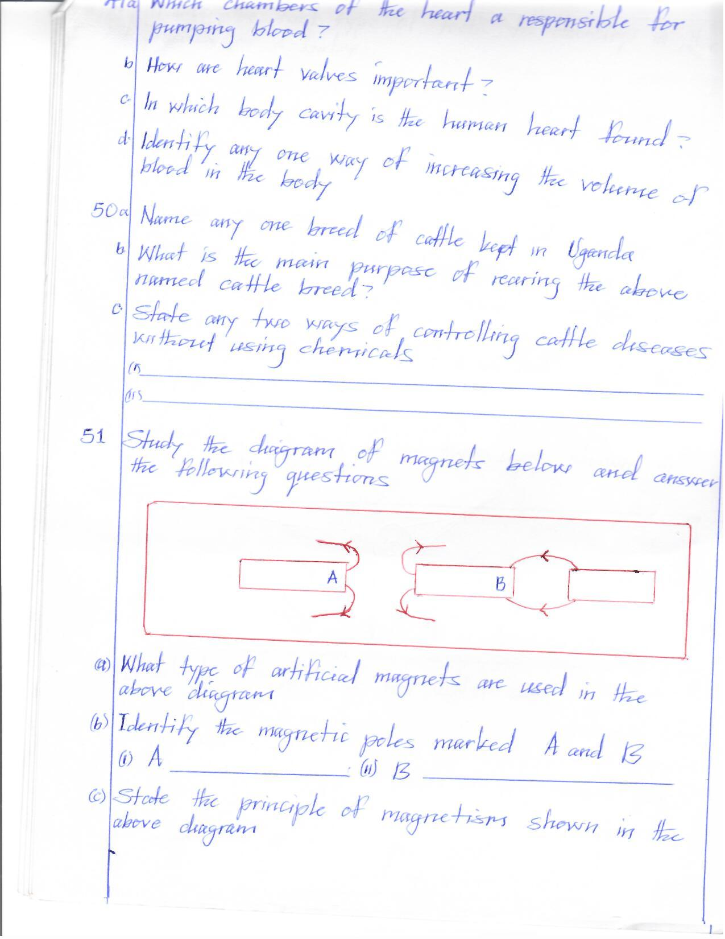

a) What type of artificial magnets are used in the above diagram?

____________________________________________________________________

b) Identify the magnetic poles marked A and B.

i) A________________________________________________________________

ii)B_________________________________________________________________

c) State the principle of magnetism shown in the above diagram.

____________________________________________________________________

1. a) Name the first type of teeth to develop in the mouth of a baby.

____________________________________________________________________

b) Which set of teeth is possessed by adult people?

____________________________________________________________________

c) Identify any one habit which affects the teeth.

____________________________________________________________________

d) How can you care for your teeth?

____________________________________________________________________

1. a) In one sentence, give the meaning of posture.

____________________________________________________________________

b) Give two importance of maintaining a good posture.

i)___________________________________________________________________

ii)___________________________________________________________________

c) State any one danger of a bad posture to the body.

____________________________________________________________________

1. Hot water was put in the two cups shown in the diagram below

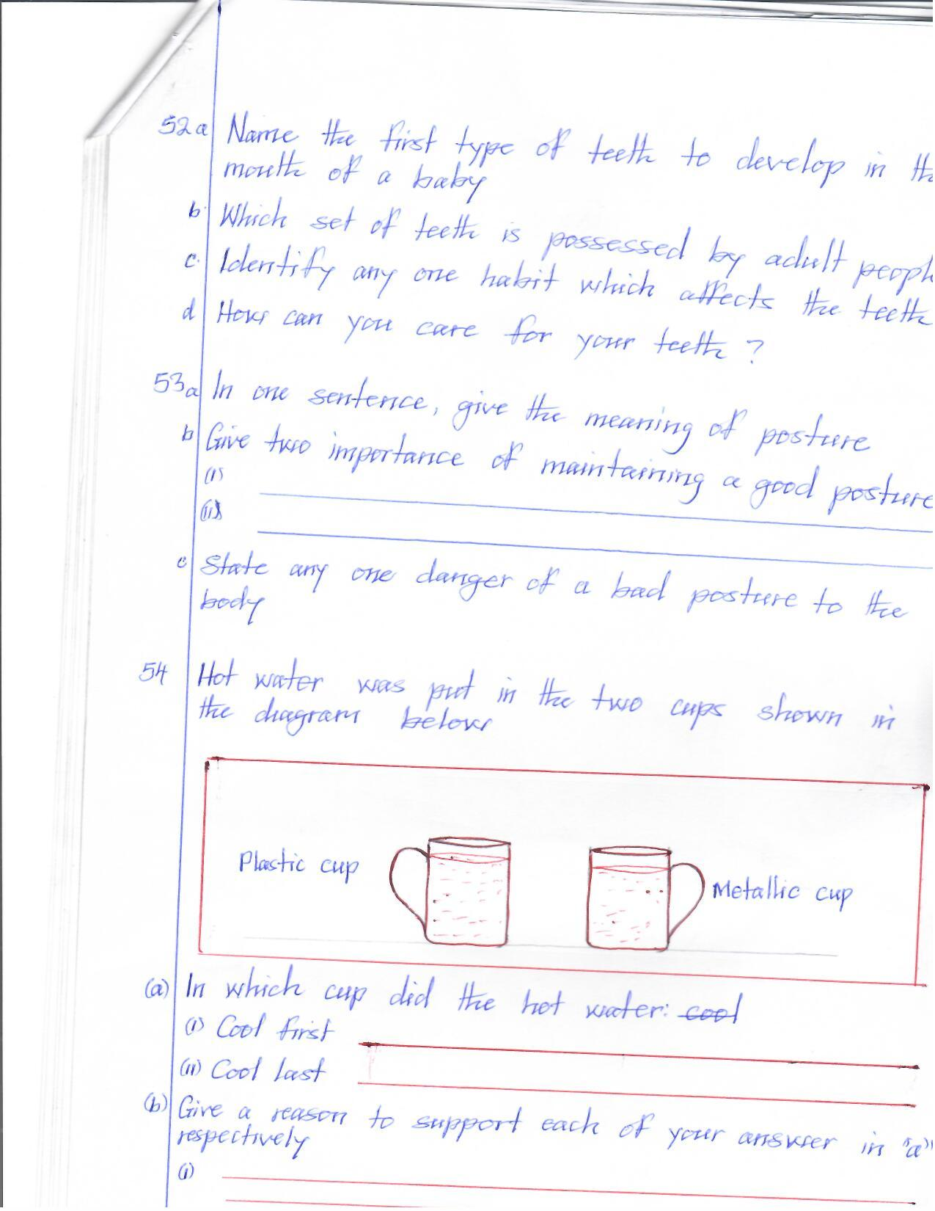

a) In which cup did the hot water

i) cool first ____________________________________________________________________

ii) cool last

____________________________________________________________________

b) Give a reason to support each of your answer in “a” respectively

i)___________________________________________________________________

ii)___________________________________________________________________

1. Complete the table below by filling in the blank spaces

|  |  |  |
| --- | --- | --- |
| **Vector** | **Disease** | **Cause** |
| i)___________________ | Lyme disease | Bacteria |
| Cockroach | Poliomyelitis | ii)__________________ |
| Simulid | iii)___________________ | Onchocerca volvulus |
| Water snail | iv) ___________________ | Schistosome |

**END**